Nabeel Ahmed
D208 Performance Assessment
04/23/2025

- Describe Purpose:
  - Does a customer’s tenure, income, and bandwidth usage significantly predict their monthly charge?
  - The primary goal of this data analysis is to build a multiple linear regression model that predicts a customer’s monthly charge based on key characteristics, specifically their tenure, income, and bandwidth usage. Ultimately, the insights gained from this analysis will help the company improve its revenue forecasting and tailor its services to better align with customer behavior and value.
- Description of Multiple Linear Regression:
  - Four Assumptions:
    - Linear: The relationship between the dependent variable and each independent variable should be linear. (Osborne)
    - Independence of Errors: The residuals (errors) must be independent of each other. (Osborne)
    - Homoscedasticity: The variance of the residuals should remain constant across all levels of the independent variables. (Osborne)
    - Normality of Residuals: The residuals of the regression should be approximately normally distributed. (Osborne)
  - Two Benefits of Python
    - Efficiency and Reusability: Python makes it easy to write code once and
reuse it later. I can keep my process consistent, tweak it as needed, and
avoid redoing everything from scratch every time.
    - Great Tools Built-In: Python has everything I need such as, pandas for
cleaning data, matplotlib and seaborn for charts, and statsmodels and
scikit-learn for running regression models. It saves a ton of time and keeps everything in one place.
  - Multiple linear regression is the right tool for this project because I’m trying to
predict a continuous value, the customer's monthly charge, based on several input variables like tenure, income, and bandwidth. This method lets me see how much each factor affects monthly charges while controlling for the others.
- Univariate Statistics:
  - Data Cleaning Goals
    - Removed Missing Values: I checked the dataset for null values and found that Income, Tenure, and Bandwidth_GB_Year had some missing entries. I filled them in using either the mean or median, depending on the shape
of the distribution.
    - Dropped Unnecessary Columns: There were a lot of columns unrelated to my research question (like Customer_id, Zip, State, etc.), so I dropped
anything I didn’t need to keep the dataset clean and focused.
    - Checked for Duplicates: I ran a quick check for duplicate rows and
removed any that were repeated.
    - Verified Data Types: I confirmed that all my independent variables and
the dependent variable were numerical, which is necessary for regression modeling
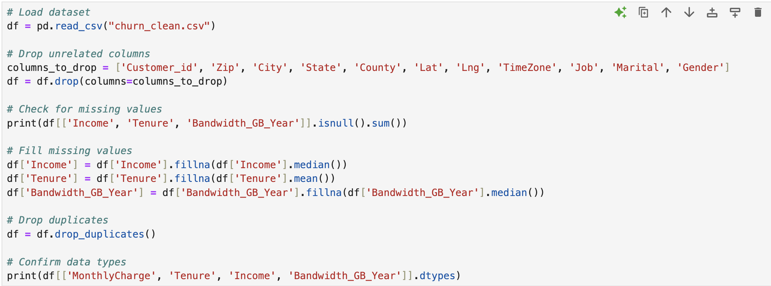
  - MonthlyCharge (Dependent Variable):
Mean: $172.62
Min: $79.98
Max: $290.16
Standard Deviation: $42.94
Tenure (months with the company):
Mean: 34.53 months
Min: 1.00
Max: 72.00
Standard Deviation: 26.44
Income (annual income in dollars):
Mean: $39,806.93
Min: $348.67,
Max: $258,900.70
Standard Deviation: $28,199.92
Bandwidth_GB_Year (internet bandwidth usage per year):
Mean: 3392.34 GB
Min: 155.51
Max: 7158.98
Standard Deviation: 2185.29
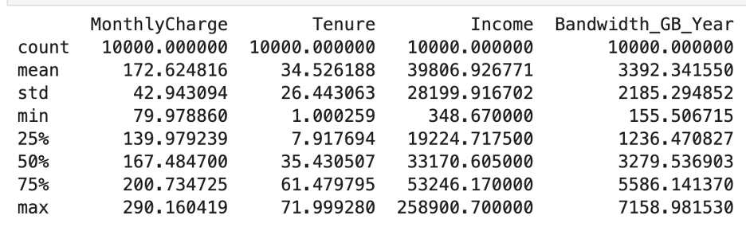
  - Univariate Visualizations:
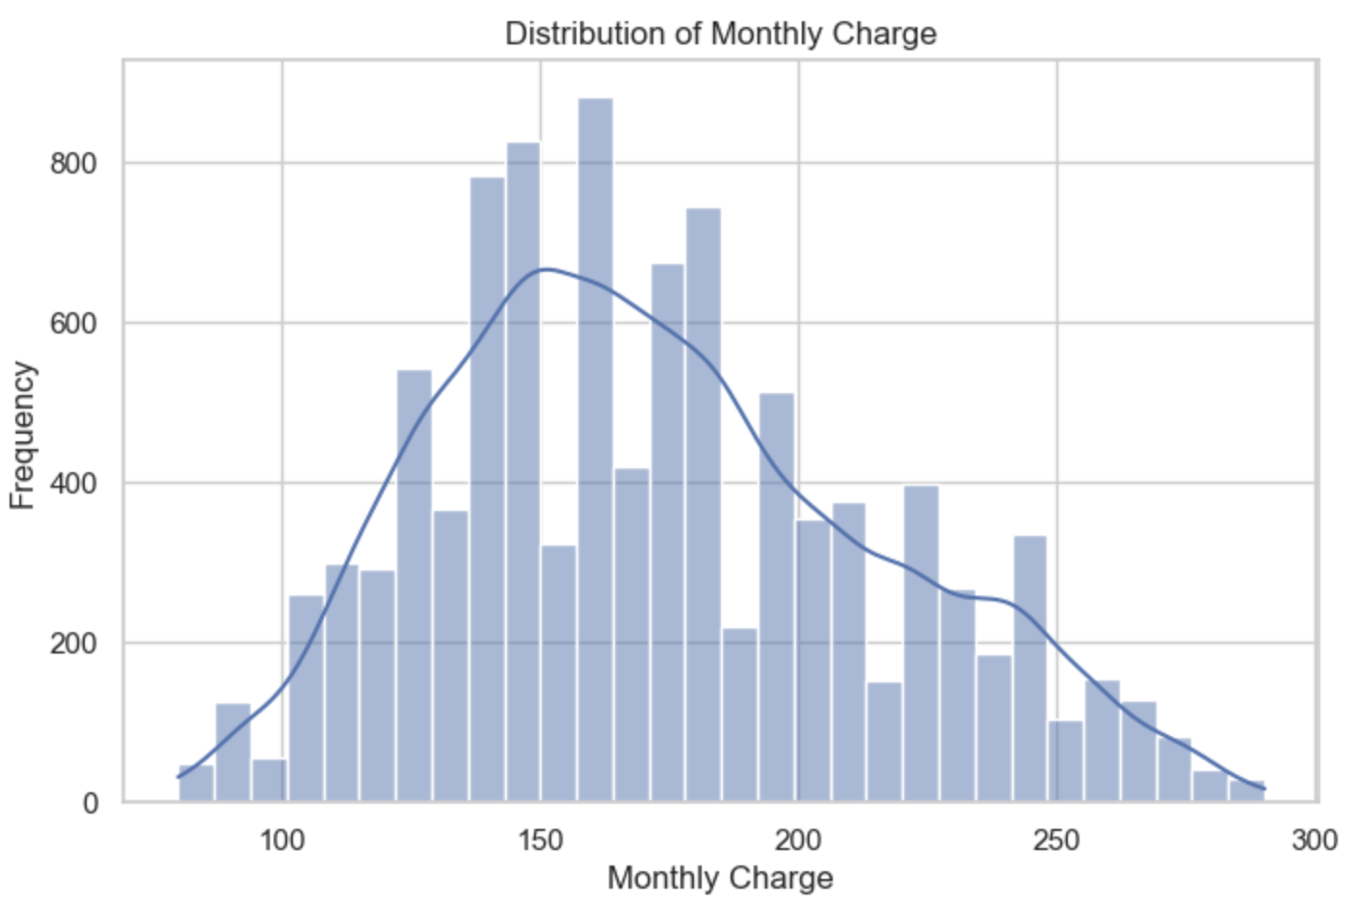
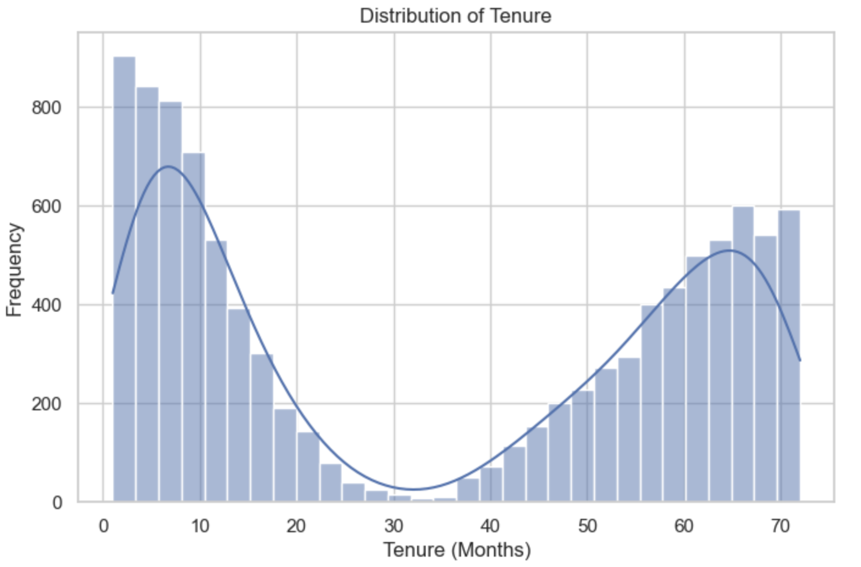
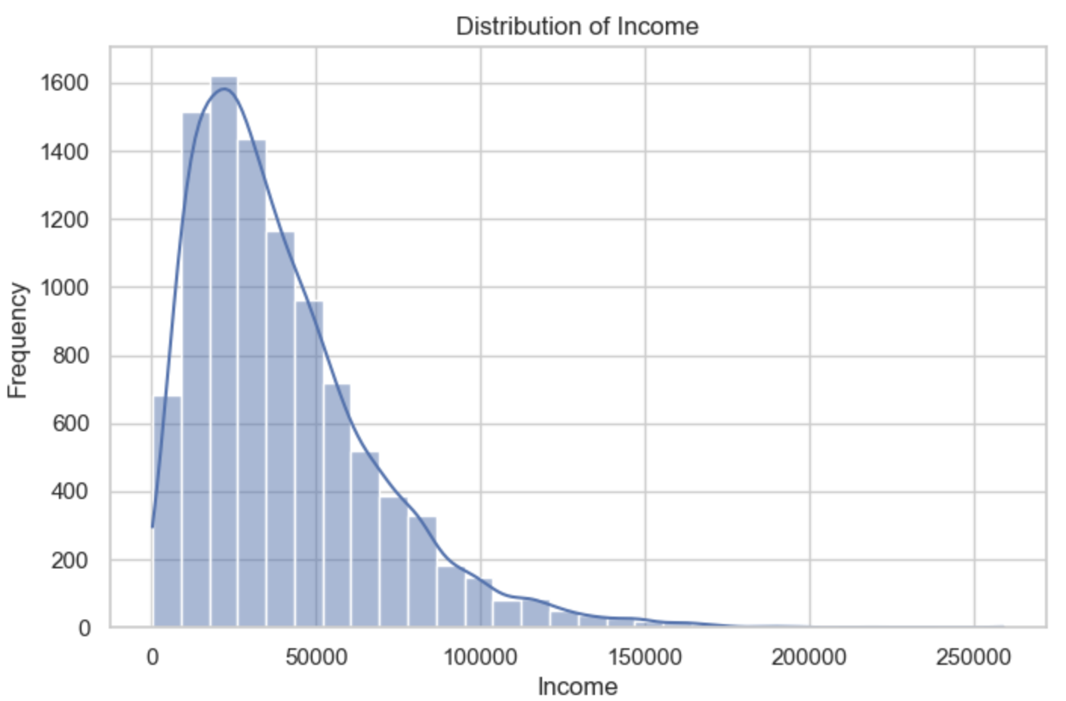
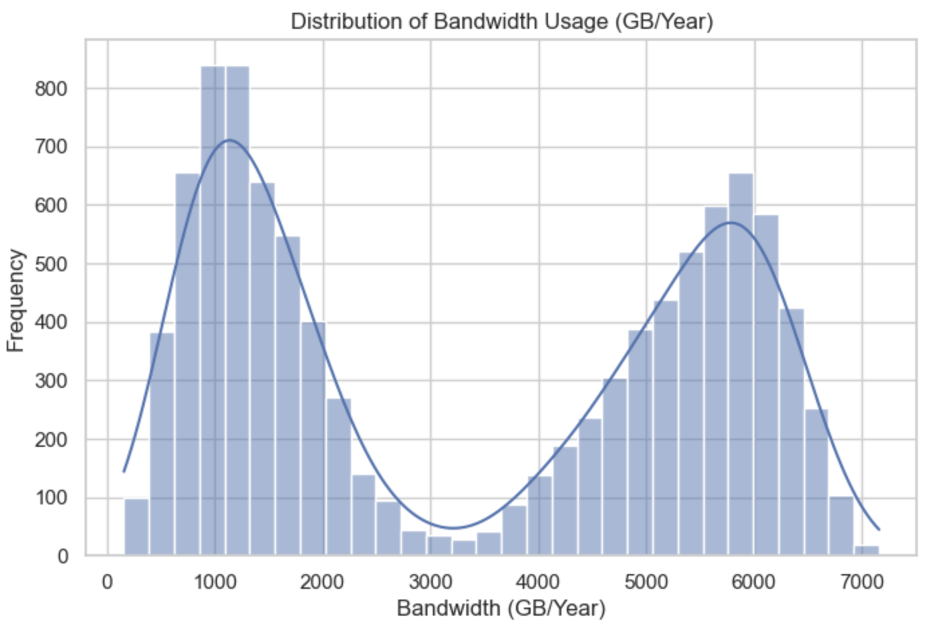
-(Bobbitt)
Bivariate Visualizations with Dependent Variables
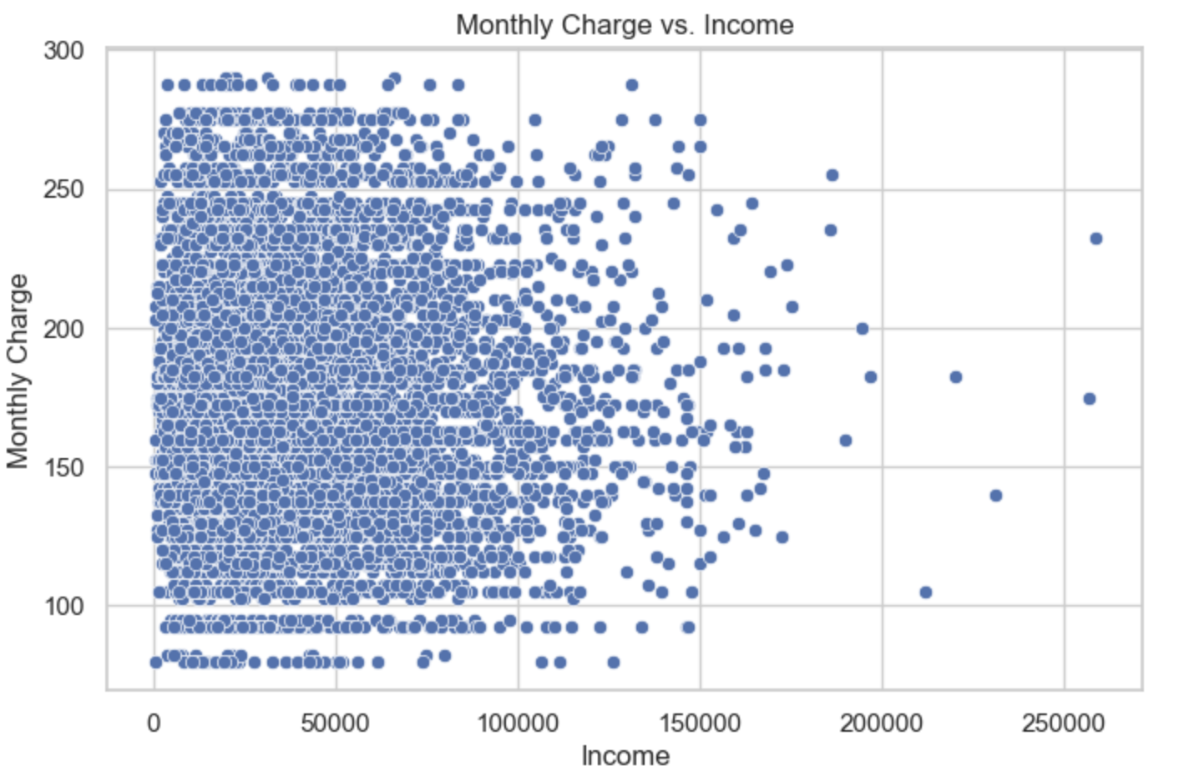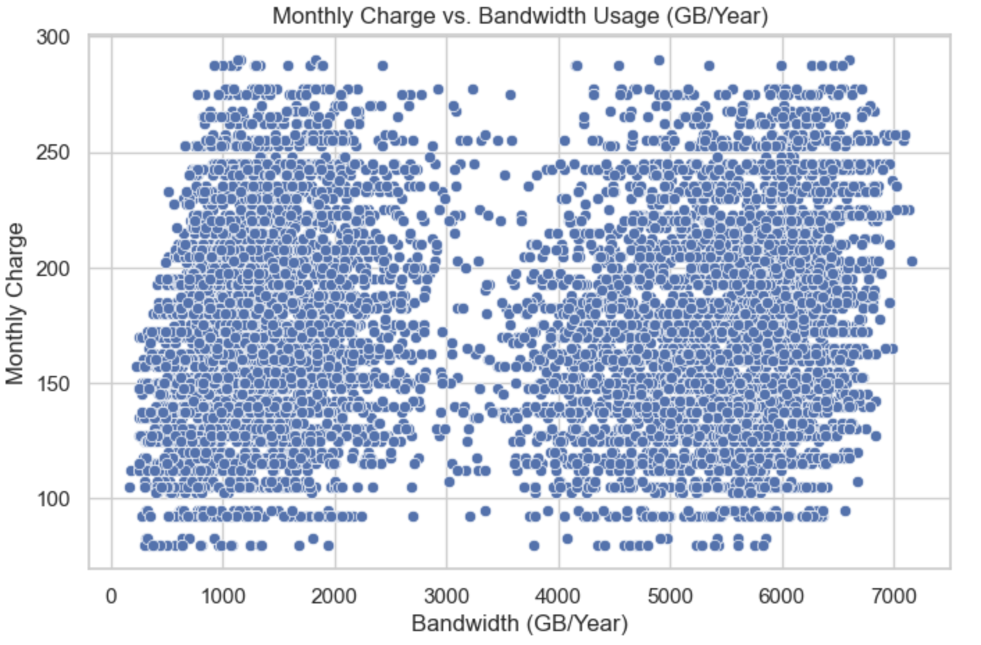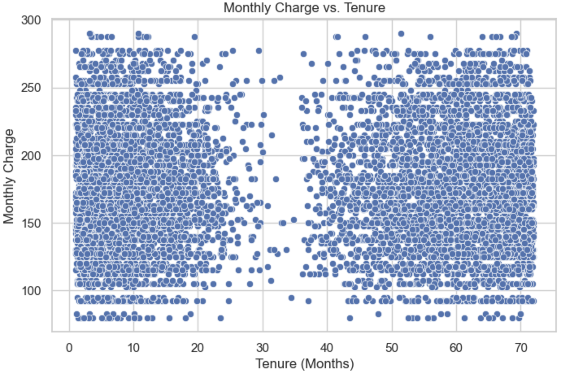
  - The goal of data transformation was to ensure all variables used in the regression model (Tenure, Income, and Bandwidth_GB_Year) were scaled consistently and
ready for modeling. Since these variables are on very different numeric scales,
standardizing them helps the model interpret their influence more fairly.
Steps for Data Transformation:
    - Standardized the independent variables using z-score scaling (mean = 0,
std = 1).
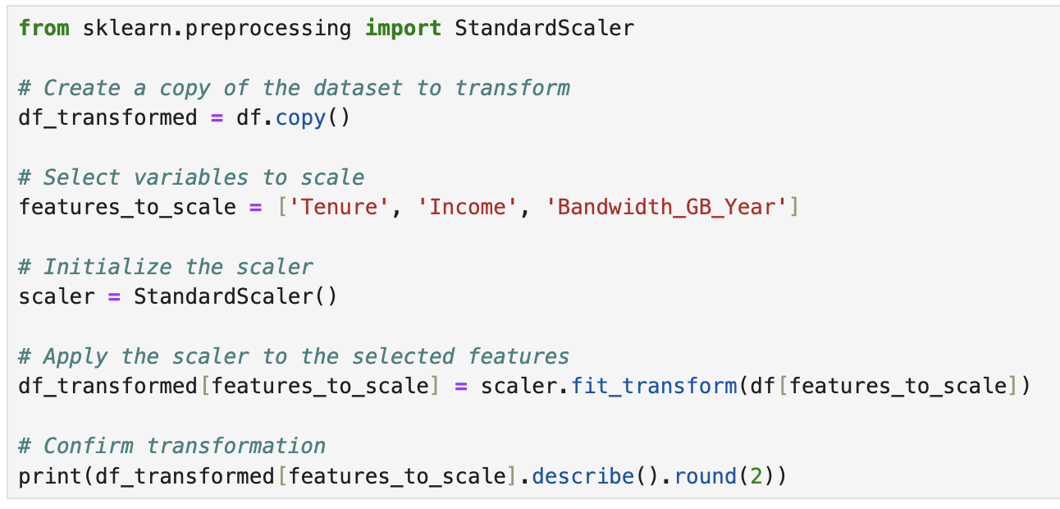
    - Kept the dependent variable MonthlyCharge in its original form since it's
the target for prediction.
  - Cleaned CSV file attached to submission called:
“churn_prepared_for_regression.csv”
- Bivariate Graphs
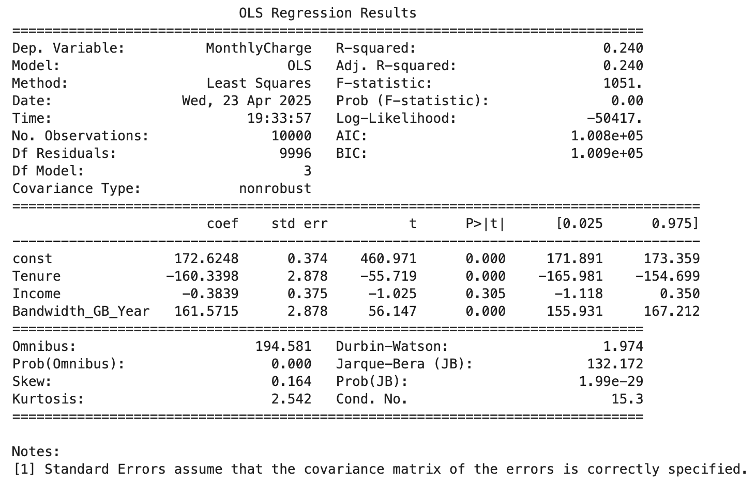
  - Initial Multiple Linear Regression Model
  - To reduce the initial multiple linear regression model, I used p-values as the
statistically based feature selection method. In the model above, each independent variable has an associated p-value that indicates whether it is statistically
significant in predicting the dependent variable (MonthlyCharge). A common
threshold of 0.05 is used to determine significance. If a variable’s p-value is
greater than 0.05, it means there isn’t strong evidence that the variable contributes meaningfully to the model, and it can be considered for removal. (Banerjee)
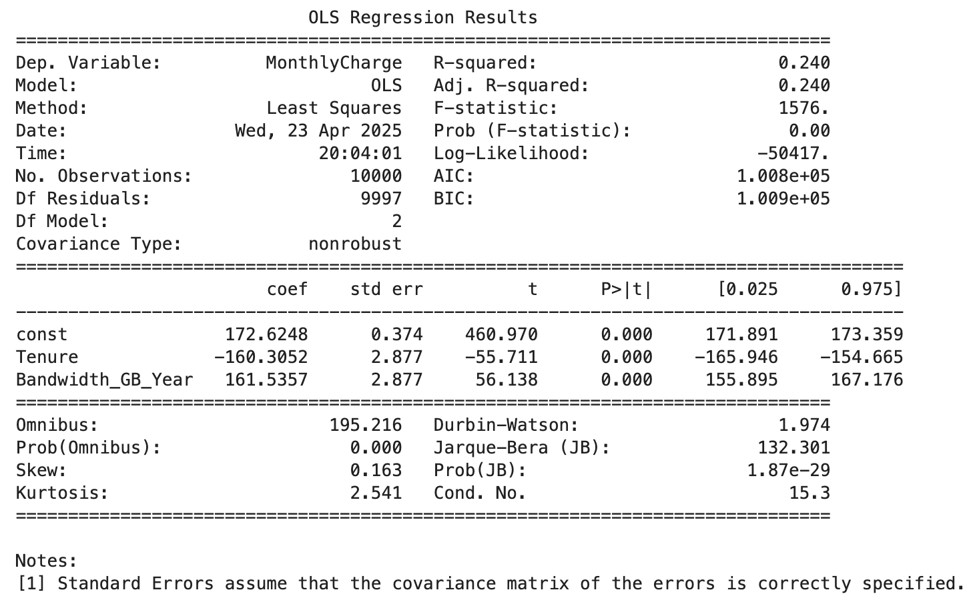
  - Reduced Linear Regression Model
- Implications of Data
  - I created both an initial and a reduced multiple linear regression model. The initial model included all three independent variables: Tenure, Income, and
Bandwidth_GB_Year. Based on the p-values, Income was not statistically
significant, so it was removed in the reduced model.
I used Adjusted R-squared as the evaluation metric to compare the two models, since it accounts for the number of predictors and helps prevent overfitting. The
Adjusted R-squared values were 0.240 for the initial model and 0.240 for the
reduced model. The lack of change in this metric indicates that removing Income did not reduce the model's explanatory power, making the reduced model a
simpler and more efficient choice.
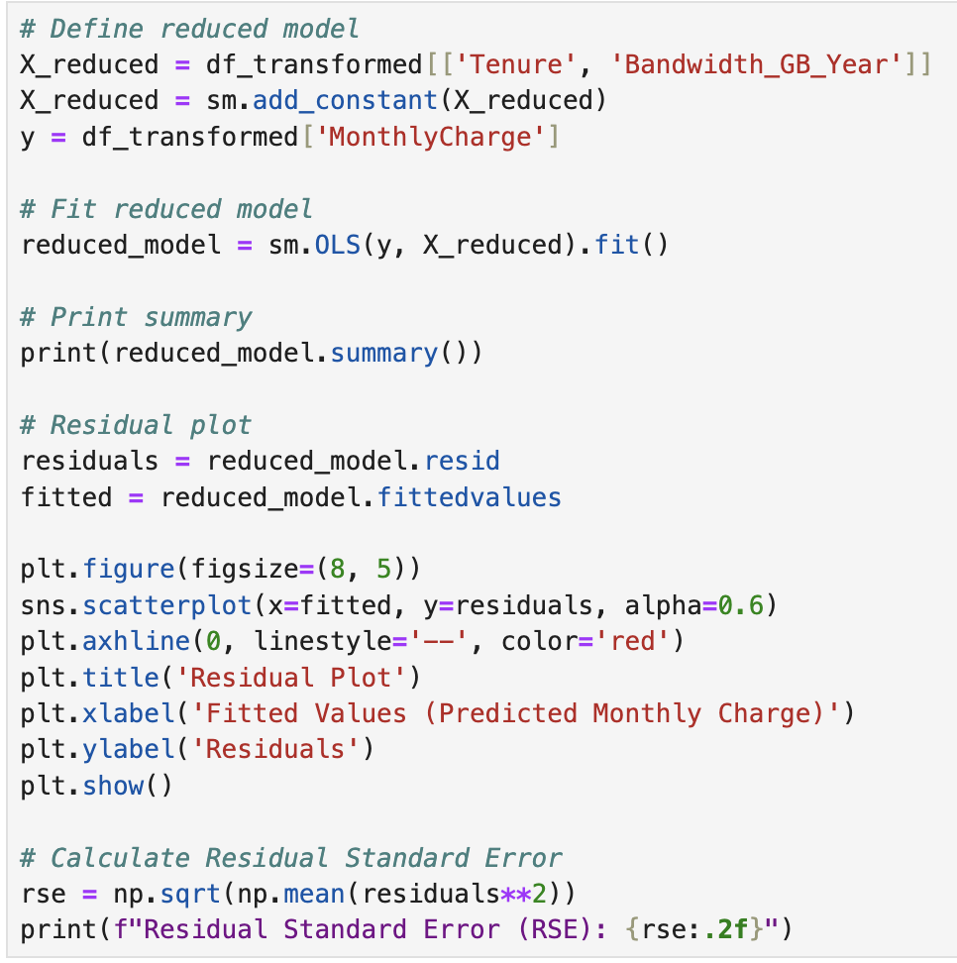
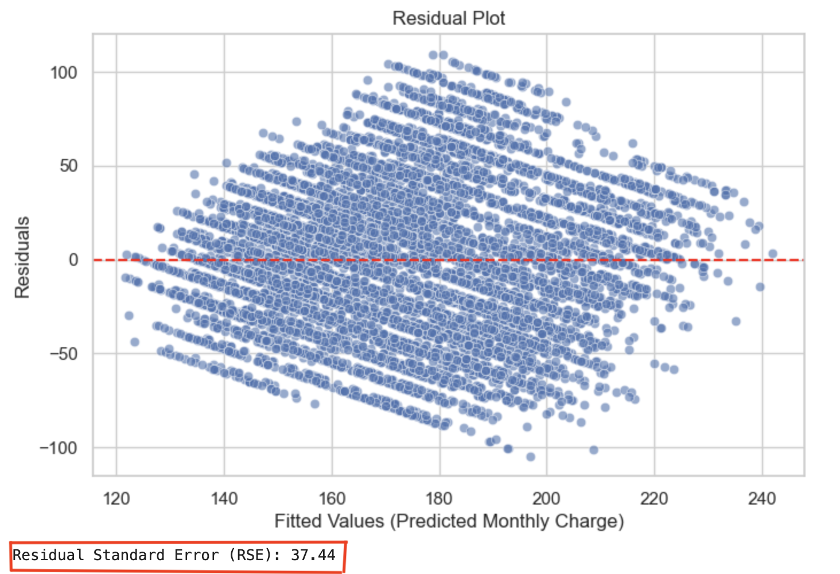
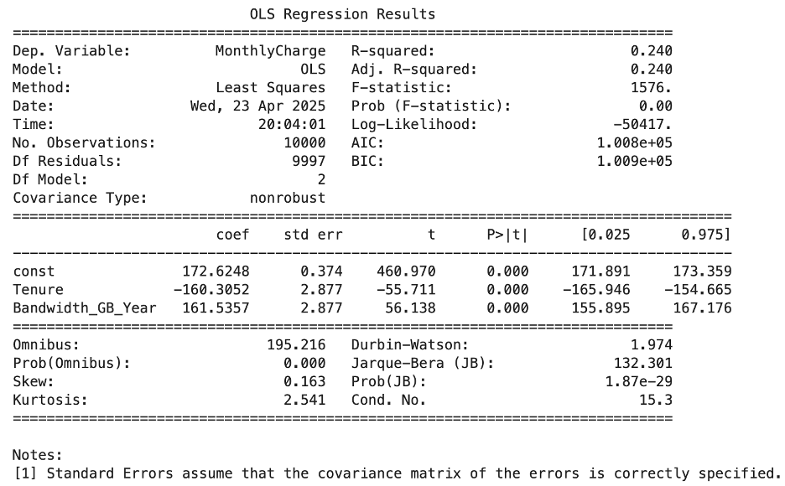
  - Output and Calculations with Summary, Residual Plot, and the model’s Residual Standard Error
  - Executable code is attached and is called: “D208.ipynb”
- Data Summary:
  - The regression equation for the reduced model is: MonthlyCharge = 172.62 − 160.31 × Tenure + 161.54 × Bandwidth_GB_Year. The coefficient for Tenure
indicates that as tenure increases, monthly charges decrease. The coefficient for
Bandwidth_GB_Year shows that as bandwidth usage increases, monthly charges
increase. Both predictors, Statistical and Practical, are statistically significant
based on their p-values. The adjusted R-squared of the model is approximately 0.24, showing moderate explanatory power. A limitation of the model is that it does not include other potentially important variables and assumes linear relationships.
  - Based on the results of the reduced regression model, I recommend focusing on
pricing strategies that consider both bandwidth usage and customer tenure.
Customers who use more bandwidth are charged more, while longer-tenured
customers tend to be charged less. The organization should evaluate whether these patterns align with current business goals and consider adjusting pricing or
retention strategies accordingly.
- Panopto Link: https://wgu.hosted.panopto.com/Panopto/Pages/Viewer.aspx?id=7eb1e622-ecee-43ee-a24c-b2c9003500ab
- Sources:
Ashwini. (2023, November 27). A quick guide to bivariate analysis in python. Analytics Vidhya. https://www.analyticsvidhya.com/blog/2022/02/a-quick-guide-to-bivariate-analysis-in-python/

Banerjee, C. (2023, November 14). P value and feature selection. Medium. https://medium.com/@chandradip93/p-value-and-feature-selection-629bec71d828

Bobbitt, Z. (2021, November 22). How to perform Univariate analysis in python (with examples). Statology. https://www.statology.org/univariate-analysis-in-python/

Osborne, J. W., & Waters, E. (2002, January 2). Four assumptions of multiple regression that researchers should always test. Practical Assessment, Research, and Evaluation. https://openpublishing.library.umass.edu/pare/article/id/1461/#:~:text=Therefore%2C%20we%20will%20focus%20on,measurement%2C%20homoscedasticity%2C%20and%20normality.

